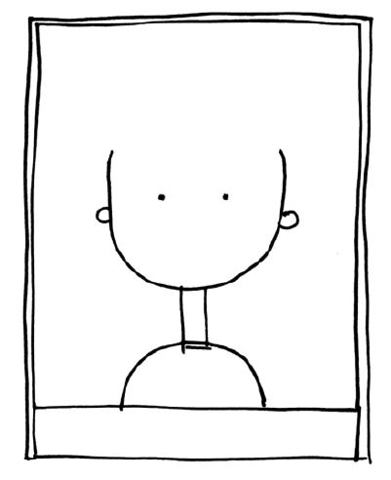

NAME

Insert Resolution Paragraph Here